

Department | FED
Subject | DSA-2
Academic Year | I-III Semester (2025-26)
Faculty Name | Dr. Sreeram Murthy
Student Name | P.Harsha Vardhan
Roll Number | 2520090180
Branch | CSIT
Course Outcome | CO3

Case Study Topic: X (Twitter) – Retweet Reach Prediction Using
Work Done Summary
In this case study, we analyzed the retweet reach prediction system used by X (Twitter). When a user posts a tweet, the platform estimates how many users can potentially view the tweet within the first ten minutes. This prediction is important for advertisement pricing, trend detection, and content recommendation systems.
The prediction model uses a bounded Breadth First Search (BFS) on the follower graph. Starting from the original author, the algorithm explores followers level by level up to a maximum depth of three hops. Any users beyond depth three are ignored because their probability of interacting with the tweet is considered negligible.
A key challenge is audience overlap. Multiple users may follow the same account, causing the same user to be reachable through different paths. Without a visited-set, the BFS may count the same user multiple times, leading to incorrect reach estimates.
The platform operates under a strict service-level agreement (SLA) requiring prediction generation within 500 milliseconds per tweet (p99 latency). Therefore, efficient graph traversal and duplicate elimination are critical.
The miniature follower graph consists of nine users:
A → B, C
B → D, E
C → E, F
D → G
E → G, H
F → H, I
The source user is:
A
Maximum BFS depth:
3

1. Case Study Problem Explanation
(a) Bounded BFS Traversal
The BFS begins from source node A.
Visited Set Initially:
{A}
Queue Initially:
[(A,0)]

Iteration | Node (Depth) | New Users | Queue After Processing
1 | A(0) | B,C | (B,1),(C,1)
2 | B(1) | D,E | (C,1),(D,2),(E,2)
3 | C(1) | F | (D,2),(E,2),(F,2)
4 | D(2) | G | (E,2),(F,2),(G,3)
5 | E(2) | H | (F,2),(G,3),(H,3)
6 | F(2) | I | (G,3),(H,3),(I,3)
7 | G(3) | None | (H,3),(I,3)
8 | H(3) | None | (I,3)
9 | I(3) | None | Empty

Final Reachable Users
Excluding source node A:
{B,C,D,E,F,G,H,I}
Total Reach:
8 users

Nodes with Multiple Incoming Edges
User E
Reachable from:
B → E
C → E
B discovers E first.
Therefore predecessor stored:
B
When C later encounters E, it is already present in the visited-set and is ignored.

User G
Reachable from:
D → G
E → G
D discovers G first.
Stored predecessor:
D

User H
Reachable from:
E → H
F → H
E discovers H first.
Stored predecessor:
E

Why Visited Set Prevents Double Counting
Without a visited-set:
E counted twice
G counted twice
H counted twice
This would inflate reach estimates.
The visited-set guarantees every user is processed only once, ensuring:
Reach Count = Number of Distinct Users
and preventing duplicate queue insertions.
Capacity Analysis Under the 500 ms Budget
Distinct Reach with Visited Set
Given:
Depth 1 Followers = 50,000
Average Followers/User = 500
Overlap = 30%

Depth 1
50,000 users

Depth 2
Candidates:
50,000 × 500
=
25,000,000
Applying overlap:
25,000,000 × 0.70
=
17,500,000
Distinct depth-2 users:
17.5 million

Depth 3
Candidates:
17,500,000 × 500
=
8,750,000,000
Applying overlap:
8,750,000,000 × 0.70
=
6,125,000,000
Distinct depth-3 users:
6.125 billion

Total Distinct Reach
50,000
+
17,500,000
+
6,125,000,000
=
6,142,550,000
Approximately:
6.14 billion users

Worst Case Without Visited Set
Naive BFS re-enqueues already-seen users.
Work becomes proportional to all candidate edges.
Depth 1 = 50,000
Depth 2 = 25,000,000
Depth 3 = 12,500,000,000
Total work:
12.525 billion node visits
which is significantly larger than the visited version.

Feasibility Under 500 ms Budget
Assumption:
One neighbour visit = 2 μs
Visited BFS work:
6,142,550,000 × 2 μs
=
12,285,100,000 μs
Convert:
12,285 seconds
≈ 204 minutes

SLA Check
Required:
500 ms
Actual:
≈ 12,285,000 ms
Therefore:
SLA Violated
A complete depth-3 traversal is not feasible at this scale. Production systems would require additional optimizations such as sampling, probabilistic estimation, graph pruning, or pre-computed reach statistics.

OUTPUT :

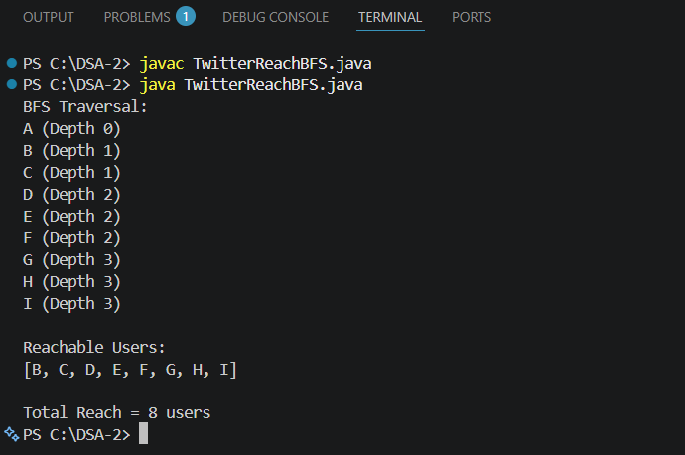

2. Time Complexity and Reach Analysis
Operation | Complexity
BFS Traversal | O(V + E)
Visited Check | O(1) Average
Queue Insert | O(1)
Queue Remove | O(1)
Reach Prediction | O(V + E)

Key Analysis Takeaways
1. Correct Reach Prediction
The visited-set ensures that each user is counted only once, producing an accurate estimate of tweet reach.
2. Duplicate Prevention
Users such as E, G, and H are reachable through multiple paths. The visited-set prevents double-counting and redundant processing.
3. Efficient Traversal
Bounded BFS explores only nodes within three hops, significantly reducing graph traversal cost.
4. Scalability Challenge
Even with bounded depth, extremely large social graphs can exceed the 500 ms SLA budget.
5. Recommendation
For large-scale retweet prediction systems, bounded BFS should be combined with graph sampling, cached reach estimates, or probabilistic models to satisfy real-time latency

GITHUB LINK : https://github.com/harsha-vardhann-reddy/DSA-2-Case-Study

Student Signature | Faculty Signature

